CMD RULE BOOK
THE RULES OF THE ROAD

START YOUR ENGINES –

Introduction

Hello everyone! Thank you for your interest in the CATCH MY DRIFT Series powered by CLEAN CULTURE. These rules were chosen to offer the competitors equitable, yet safe, events. If anyone requires clarification on any rule set forth herein, they are directed to email those inquires to CMDriftJoe@gmail.com. All drivers and teams are encouraged to read these rules carefully and thoroughly. All Judged decisions are final with an appropriate means to appeal set forth herein below.

KEEP IN TUNE –

Points of Contact

Get all the latest news and updates directly from the source via:

Instagram: @Catchmydriftllc

Facebook: Catchmydriftllc

General and technical questions should be directed to CMDriftJoe@gmail.com

ROADMAP

Table of Contents

- GENERAL – FAQs
- VEHICLE ELIGIBILITY
  - Tech Requirements
  - Decal Placement
- PRACTICE
- START LINE
  - Chicane
  - Three Strike Rule
  - Initiations
- COMPETITION
  - Tandems – Elimination Rounds
  - Judging Criteria
    - Lead Driver
    - Lead Driver Deductions
    - Chase Driver
    - Chase Driver Deductions
    - Tandem Zeros
  - Tandem Initiation
  - Tandem Contact and Collisions
  - Vehicle Service During Tandem
  - Competition Timeout
    - Timeout Procedure
- THE PROTEST
  - Protest Procedure
  - Protest Times
  - Protest Costs
  - Protest Form
- CHAMPIONSHIP POINTS AND PURSE

- GENERAL FAQs

The most frequently asked questions for our series are regarding tire limitations, safety equipment, and driver caps. The following information will address those concerns.

All information regarding vehicle qualification and requirements are contained here within the rules.

It is the DRIVER’S RESPONSIBILITY to present their vehicle to CMD’s tech inspectors in the tech paddock and successfully pass inspection. No refunds will be issued for FAILURE TO PASS tech.

“WHAT SIZE TIRES ARE WE ALLOWED TO RUN?”

The MAXIMUM TIRE SIZE allowed in the CMD/CLEAN CULTURE SERIES is 265mm tread width. The width of the tire will be determined by the lettering on the tire. CMD understands that these widths vary from manufacture to manufacture and thus are so qualified on that basis. Treadwear rating must be 100 or higher. The tire must also be DOT approved.

The width limit (265mm) pertains to the rear tires only. A 265mm “drift“ tire is quite common and usually more affordable than other sizes (i.e. Kenda). The 265mm tire is of sufficient size such that big horsepower cars can compete and allow lesser horsepower cars to be competitive. CMD considers this an equalizer that will allow the best drivers to garner valuable series points. If a driver or race team uses a tire larger than a 265 during the competition portion of the event and it is discovered, they will immediately be disqualified. In the discretion of the CMD organizers, offenders may be banned from competition in remaining series events for said offense.

“WHAT ARE THE TECH REQUIREMENTS FOR COMPETITION?”

The minimum safety requirements are listed on our tech form here.

All vehicles are required to have a six point (6 pt) roll cage with door bars. Roll cage material must be seamless SAE 1020 or SAE 1025 mild steel, DOM, or chromoly. ERW tubing is not permitted. I’ll roll cage tubing must be a minimum of 1.5×.095 inch. The minus tolerance for wall thickness should not be less than .010 inch below the nominal thickness.

Padding is required in any area where the drivers head may make contact with a roll cage bar. Padding is also required in the lower section of the driver side cage structure. This is anywhere the driver’s head or torso may encounter the structure. Padding must meet SFI spec 45.1 or FIA 8857–2001. Insulate your plumbing with pool noodles, not your brain.

“HOW DOES QUALIFYING WORK?”

The number of drivers will be capped at forty-eight (48). Following the mandatory drivers meeting, a random drawing will take place. Qualifying will be eliminated because it is both time-consuming and a boring to watch. The best driver that day will win the event regardless.

CMD is proudly known for delivering an abundance of seat time for its drivers. We want to keep drifting fun and we do not want to hold an event, where due to time constraints, a driver may only get limited time on the track.

It is inevitable that a driver will be giving a bye, but everyone’s starting position is random. How a competitor finishes is almost exclusively decided by driving skills and their cars mechanical durability. Competition numbers will be given to the competitors following the drivers meeting. This number must be displayed on the windshield of their car. The higher number of the two combatants will lead on the first run.

Below is an example of the bracket used in our competition.

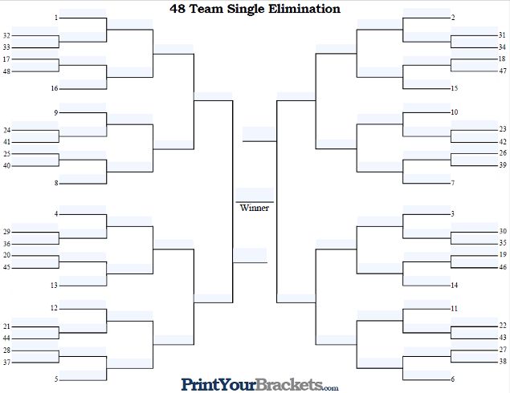

- VEHICLE ELIGIBILITY

  - Tech Requirements

ALL VEHICLES must pass CMD’s technical inspection. A driver will receive a sticker after successfully passing the inspection. That sticker must be attached to the vehicle.

Roll cage requirements are set forth herein above in the FAQs section (under heading number 1).

Drivers must have a fixed back seat that is securely fastened to the vehicle.

A four or five points safety harness must pass through the seat bosses and have one common release point. The lap belts should be mounted rear of the pelvis. The shoulder belts shall be wrapped around the roll cage structure using a 3-bar adjuster or mounted to a bracket using Grade 5 or better hardware.

Reference the images below for harness placement and angles.

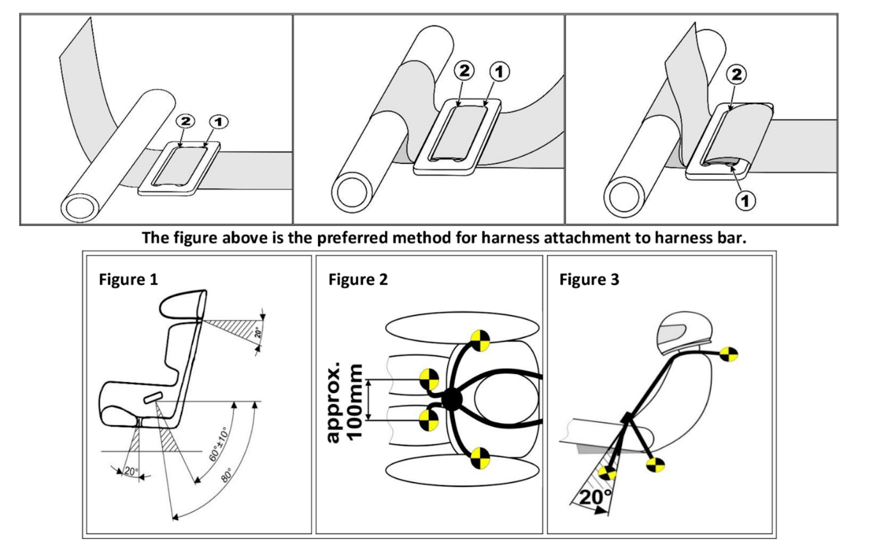

  - Decal Placement

Drivers are required to have the CLEAN CULTURE/CMD WINDSHIELD BANNER displayed during the competition. Each driver will be provided with one banner. Additional banners will be Twenty Five Dollars ($25.00). There may be other contingency decals to be displayed for additional prizes. Contingency decals shall be announced at the driver’s meeting if available and are optional. Prizes will only be awarded to those using the decals. Show your support for those that support us.

- PRACTICE

The purpose of eliminating driver qualifying is to maximize practice for our drivers. Practice equals seat time. It takes 10,000 hours to become an expert in anything. The more seat time we have, the more fun and challenging our competitions will be against each other.

The standard “lead” and “follow” lanes will be present. If a driver chooses to do a solo run (single driver), please indicate that by holding up your index finger (for one driver) or illuminate your hazard lights for those that may have a disability or are unable to use their hand/finger.

- START LINE

The start line light will be controlled by a grid operator. The grid operator will solicit the readiness of each driver. After both drivers indicate their readiness, the operator will raise his hands signaling READY.

The “follow” driver may leave the line at any time after the grid operator’s hands are raised, but they are not allowed to impede the lead drivers line in anyway.

  - Chicane

Chicanes maybe used this season at the discretion of the judging panel.

If the lead driver hits one or more cones within the starting chicane the battle will be restarted by either the grid operator or a trackside flagger.

The location of the grid operator and the flaggers will be determined at the drivers meeting prior to the competition.

  - Three Strike Rule

A strike will be given if a lead driver hits one or more cones within the chicane.

An additional strike will be given for each subsequent assault upon the cones.

On the third restart, if the lead driver hits a cone, that driver will be awarded an automatic incomplete.

The judges may call for a restart if they determine a driver exhibited unsportsmanlike behavior. If such a restart occurs, it shall act as a strike. Criteria for unsportsmanlike behavior is subjective and decisions on such are in the sole discretion of the judges and will be discussed at the drivers meeting.

In the unlikely event of a chase driver hitting a cone, whether intentionally or accidentally, no restart will be initiated.

  - Initiations

The vehicle must be sideways as it passes the last initiation point. Initiation points are designated by a set of three cones placed on the track. If a competitor’s vehicle is not sideways by the third standing cone they will receive an automatic zero. All drivers are limited to a two-move initiation prior to the third cone.

- COMPETITION

  - TANDEMS – ELIMINATION ROUNDS

Drivers will be paired against each other in a single elimination bracket. As mentioned hereinabove, the bracket will be filled via a random drawing which will assign a number to each competing driver. The drawing will occur during the driver’s meeting.

A battle consists of two runs, with each driver taking a turn as the lead driver. The driver with the larger number will take the lead on the first run and they will follow on the second run.

The lead vehicle is expected to drift a perfect line consistent with a 100-point (perfect) qualifying run. The criteria for this shall be set forth by the judges in the driver’s meeting. The lead driver shall receive deductions for mistakes made.

The chase vehicle is expected to follow the line of the lead vehicle and essentially use the lead vehicle as a moving clipping point. During the chase, the chase vehicle should try to match or better the angle of the lead vehicle The chase vehicle is encouraged to be as close to the lead vehicle as possible. The chase driver should expect to receive deductions for mistakes made. Forced errors brought on by the lead vehicle/driver will not be cause for point deductions to the chase vehicle.

If a vehicle is broken or retired and does not make the starting grid by the call of the battle, the remaining driver must make a bye run to move on in the competition. The same track rules apply to the loan driver, just as if in a tandem. (i.e., do not hit cones, two move initiation limit and be sideways by the last initiation cone).

  - Judging Criteria

    - Lead Driver Expectations

      - Drift a perfect line consistent with a 100-point qualifying run.
      - Drift a chaseable lead run.
      - Comply with all zone requirements, specifically clips and de-acceleration zones.

    - Lead Driver Deductions

      - Shallow angle.
      - Incorrect/off line.
      - Poor transitions.
      - Attempting to distance the lead vehicle from the chase vehicle by compromising line, angle, and/or style.

    - Chase Driver Expectations

      - Initiate no later than the lead car.
      - Maintain proximity.
      - Match or better the lead vehicle’s angle.
      - Match lead vehicle’s line/transitions.

    - Chase Driver Deductions

      - Cutting the line compared to the lead vehicle.
      - Less angle than the lead car.
      - Location and timing of initiation.
      - Transition timing.
      - Overall driving compared to the lead vehicle.

    - Tandem Zeros

      - Two (2) or more tires off track (subject to change based on course layout).
      - Straightening or loss of drift.
      - Over Rotating and/or spinning out.
      - The unintentional but preventable loss of a vehicle part(s) including but not limited to hoods, doors, trunk lids, fenders, passengers, and/or wings (air foils). Auto parts lost due to contact during the battle do not constitute a point deduction or zero.
      - Failure to be at the start line when your competition run is called. (Please be courteous to your fellow drivers. If you arrived just in time you are late. Please be a few minutes early and ready to go with all safety measures/gear in place).
      - Being at fault for contact that results in the other vehicle making a major mistake. (Such contact may be considered as unsportsmanlike conduct at and in the Judge’s discretion and may also result in a disqualification).
      - Hitting a rear zone marker with any part of the vehicle forward the rear axle.
      - Hitting a front clipping point marker with the leading side of the car.
      - A chase driver intentionally falling out of drift and/or not chasing a lead driver after a perceived mistake which may lead to an incomplete run by the other.
      - A lead run consisting of multiple mistakes that is deemed an unchaseable run.
      - Three consecutive restarts from the chicane cones or an official’s call. If a chase vehicle does something that results in a zero, the lead vehicle must still complete the lab or both drivers will receive a zero.

  - Tandem Initiation

    - Single File Initiation
    - Lead driver can initiate using any method they desire (clutch kick, e-brake, feint)
    - Lead driver has the right of way from the start line to the initiation point.
    - Lead driver must exhibit a fully committed approach to the initiation point and will be held accountable if any mistakes or issues arise at the start line and/or initiation point.
    - Chase driver must not impede the lead driver in any way, doing so will put the chase driver at a disadvantage.
    - Chase driver may position their vehicle anywhere behind the lead vehicle if it does not impede the lead vehicle’s ability to initiate.
    - Violations of initiation procedure may result in a restart.

  - Tandem Contact and Collisions

      - Lead Vehicle
If the lead driver goes off-line, lose his drift, or has a change in momentum that causes the chase driver to have a collision with the lead driver, the lead driver may be deemed at fault. Each judge will use his discretion and assign fault.

      - Chase Vehicle
If the chase vehicle has a collision with the lead vehicle while the lead vehicle is fulfilling all the lead driver requirements and adhering to all zones, then the chase driver shall be damned at fault.

    - Damage Due to Collision

      - If your vehicle is damaged as a result of the fault of the other driver, you will be allotted 15 minutes to fix your vehicle. It will not be required that you use your competition time out at that time.
      - The driver judged to be at fault is not permitted to touch their vehicle unless they use a competition time out. If one is available to them.
      - And if the vehicle deemed not at fault is unable to be repaired within the allotted time, they would move on up in the bracket, but would not be allotted any more time to fix their vehicle or compete. (i.e. Vehicle B hits vehicle A in the top eight battle. Vehicle A cannot be repaired because of vehicle B’s actions. Therefore, Vehicle A will move on to the final four but would not be permitted to battle in the final four. Vehicle B is then out of the top eight.)
      - Should the scenario occur as mentioned above in the final battle of the evening, CMD reserves the right to award extra time to the car that was judged not at fault. A running, driving, sideways battle is the desired result of the days competition.

    - Tandem Tire Debead or Damage

      - Vehicles are not permitted to leave the start line with a tire exhibiting a debeaded condition.
      - Rear tire changes will not be allowed during the competition time out unless the debeading has occurred. Rim or tire damage due to a collision with another vehicle may be granted a tire change allowance.
      - If the chase driver has a rear tire debead due to contact or collision avoidance with lead driver, both drivers make change tires.
      - In the event a front tire becomes damaged, officials may allow the vehicle to change the impacted front tire. This is done to ensure a good show and a good competition.

  - Vehicle Service During Tandem

    - Competitors cars are not to be serviced in any way between the chase in the lead runs of a battle. No service, alteration, adjustment, tire change, feeling, cool down, tire pressure, suspension adjustment, or any other service is permitted.
    - Rear tires are required to make two consecutive runs.

  - Competition Time Out

    - Teams may call a one-time competition time out to make any necessary repairs. Competition timeouts are not to be used for strategic purposes, only repairs. Only the driver or designated team representative will be allowed to request a competition time out. Teams will not be granted a time out if it is believed to be unwarranted. Competition timeouts are allowed to be a maximum of five minutes.
    - Tire changes are not permitted during a competition time out unless a collision has occurred that results in a tire change being mandatory to continue.
    - Competition timeouts are for repairs only, no tire pressure or suspension setting adjustments are permitted.
    - Drivers who fail to make the five minute call will be disqualified and forfeit to the opposing driver. Teams may only use one competition time out per round.
    - Competition timeouts may be called by the official if a vehicle is not present in grid. This discretion is granted to them to determine if the additional time will give the event a solid ending.

  - Competition Timeout Procedure

    - Drivers and teams may not perform any work on the vehicle prior to an official be on site and starting a five minute timer. External visual inspection is allowed, however no touching or alteration of the vehicle will be permitted.
    - The five (5) minute clock will start when the officials tell the driver/team to begin, not when that vehicle arrives at the location.
    - Competition timeouts will expire at the end of five (5) minutes or if any of the following apply:
      - Vehicle is not safe to drive.
      - Vehicle has not been safely and adequately repaired.
      - Vehicle is not ready to drive to the burnout box upon the expiration of five (5) minutes.
- PROTESTS

- Procedure

To protest a Judge’s call, you must speak with the official or competition Director. They will speak to the Judges before allowing a protest to move forward. Drivers are not permitted to approach the Judges tower for any reason once the battles have commenced. Approaching the Judges will result in an automatic disqualification and a dismissal of any lodged protest. The crew members of the disqualified driver are also included in the disqualification. Likewise, if a crew or team member approaches the Judges tower, it will result in an automatic disqualification for the driver.

Judges have a ten (10) minute time limit from the moment the protest form is turned into render a decision and relay it to the liaison for dissemination. After the decision is rendered, the battles will resume.

The liaison will deliver the decision to the driver and give them the reasoning the Judges provided. The Judge’s ruling is final and not subject to appeal. Any subsequent debate or argument over the ruling is simply a waste of time and therefore any approach or perceive movement towards the Judges tower will be interpreted as hostile. This will not only get the Driver a disqualification for the event but it may endanger their ability to continue in the series. The officials and the Judges can make themselves available for discussion after the conclusion of the event.

Definitions
SUBJECTIVE – based on or influenced by personal feelings, tastes, or opinions. (“his views are highly subjective”)
OBJECTIVE – not influenced by personal feelings or opinions in considering and representing facts.

YOU CANNOT PROTEST A SUBECTIVE CALL. – KNOW THE DIFFERENCE
(i.e. You cannot protest something such as angle in that “ I had more angle through the section” or “I had more style”. These are subjective calls)

YOU CAN PROTEST OBJECTIVE QUALIFYING SCORE-BASED CRITERIA

Example A: Driver A made a mistake that should equal an automatic zero or Driver A made a mistake that was scored a zero and should not have been.

Example B: Driver A caused Driver B’s mistake by doing something they were not supposed to such as, Driver A slowed down in a non-deceleration zone and caused Driver B to go off track.

Media footage collected outside of our approved media team and Judges tower are not approved for use in any protest review.
Cell phone footage is not admissible, do not bring us media for a protest. It will not be used.

Again, do not approach the judges, event staff, or your competitor during the event for the sole purpose of debating a judgment call that was made. It has been stressed prior, and here it is again, DO NOT APPROACH THE JUDGES for any reason during the event or you will be disqualified. If you have any questions/comments/concerns about your battle/run but are not protesting, wait until the event is completed and then asked to discuss it with the judges or track staff.

Drivers – The CMD staff encourages you to be proactive with your crew, team members, and fans by explaining to them the severity of the penalty if anyone in your group or aligned with your group were to approach the Judge’s tower. A defense stating that you cannot control your people will not end in a satisfactory result for you or your race team.

- Protesting Times

    - Top 48 before the start of Top 32
    - Top 32 before the start of Top 16
    - Top 16 before the start of Top 8
    - Top of 8 before the start of Top 4
    - Top 4 before the start of the Finals

- Protest Cost

The protesting fee is Two Hundred Dollars ($200.00) in must be submitted with the protest form. All fees must be paid before the Judges will render a decision. Should be original resolve be overturned your Two Hundred Dollars ($200.00) will be returned. Should the call stand you forfeit the Two Hundred Dollars ($200.00) regardless of the reason.

- Protest Form

Presented ONLY by a Driver or the Driver’s representatives. If others are with a Driver’s representative, then the protest will not be heard. There will be no groups coming to the judges stand or submitting protest forms. Protest forms must be presented within 15 minutes of the run. Forms must be filled out and signed by the Driver or the Driver’s representative. Driver or the Driver’s Representative (designated by an arm band provided by event staff at the Driver’s meeting) must present two hundred dollars ($200.00) cash with the Protest Form at the time of the protest.

PROTEST FORM

Name of Driver:
Name of Driver Representative:
Protests cannot be based on subjective complaints (See Rule Book for definition of subjective v. objective protests). Are you protesting an objective ruling?
Section of the track for discussion and/or for video pull or live stream timestamp:
Reason/Description of Protest:
By signing below, you are acknowledging that if your protest is found invalid, you will forfeit your two hundred dollar ($200.00) protest fee.

If the decision is overturned, you will be refunded the two hundred dollar ($200.00) protest fee, and you will be granted another protest form should you need it in the future.

Driver or Driver’s Representative |  | Date
CMD Official |  | Date

- CHAMPIONSHIP POINTS AND PURSE

Point System – We have adopted the same points system as Formula Drift Tandem Bracket. Each competitor will also receive 2 pts for participating in the event and for each one after the points will double. 1st = 2 pts; 2nd = 4 pts; 3rd = 8 pts; 4th = 16 pts; 5th = 32 pts. If you attend all five rounds you will have 62 points. You do not need to attend consecutive events to get in the bonus points but the more the merrier. Drivers from previous rounds will have access to purchase next round spots before the general public. We want to keep the drivers that support us. We are paying out large awards for each round but we will have some prizes from sponsors for the series winners and something from CMD/CC based on driver participation from the series. If you were interested in sponsoring the series, please email CMDriftJoe@gmail.com.

FOR TANDEM BRACKET COMPETITION

1st = 100

2nd = 80

3rd = 64

4th – 8th = 48

9th – 16th = 32

17th – 32nd = 16

PURSE

1ST PLACE $5,000.00 – FIVE THOUSAND DOLLARS

2ND PLACE $3,000.00 – THREE THOUSAND DOLLARS

3RD PLACE $2,000.00 – TWO THOUSAND DOLLARS

4TH PLACE – FREE ENTRY TO THE NEXT ROUND (NON-TRANSFERABLE)

